Laboratoriya ishi №9
Mavzu: CSS media queries orqali responsiv dizayn
yaratish
Fan: Web ilovalar

1. Ishdan maqsad
Veb-sahifalarni turli ekran o‘lchamlariga (kompyuter, planshet, telefon) moslashuvchi qilib yaratish uchun CSS media queries texnologiyasidan foydalanishni o‘rganish.

2. Nazariy qism
Responsiv dizayn — bu veb-sahifaning foydalanuvchi ekran o‘lchamiga qarab o‘z shaklini, joylashuvini va elementlarning o‘lchamini avtomatik tarzda o‘zgartiruvchi dizayn usulidir.
Media queries — CSS da turli qurilmalarga qarab maxsus uslublarni qo‘llash imkonini beruvchi mexanizm.
Asosiy sintaksis:
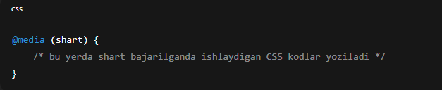Ko‘p ishlatiladigan media query turlari:
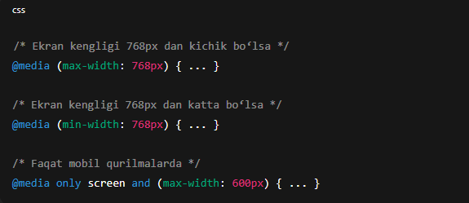

3. Amaliy qism

3.1. HTML fayl (index.html)
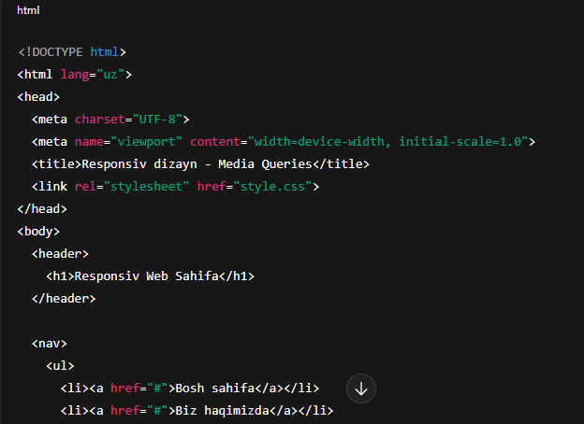
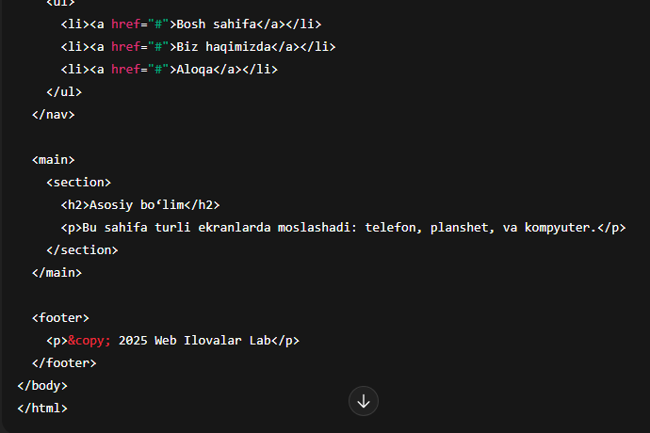

3.2. CSS fayl (style.css)
/* Umumiy uslublar */body {
font-family: Arial, sans-serif;
margin: 0;
padding: 0;
}
header, footer {
background-color: #007bff;
color: white;
text-align: center;
padding: 15px;
}
nav ul {
list-style-type: none;
display: flex;
justify-content: center;
background: #f0f0f0;
padding: 10px;
}
nav li {
margin: 0 15px;
}
main {
padding: 20px;
text-align: center;
}
/* Planshet (768px gacha) */@media (max-width: 768px) {
nav ul {
flex-direction: column;
align-items: center;
}

nav li {
margin: 10px 0;
}
}
/* Telefon (480px gacha) */@media (max-width: 480px) {
header, footer {
padding: 10px;
font-size: 14px;
}

main {
font-size: 14px;
}

nav ul {
padding: 0;
}
}

4. Natija
Ushbu kodni ishga tushirganda:
*Kompyuterda menyu gorizontal holatda ko‘rinadi.
*Planshetda menyu elementlari vertikalga o‘tadi.
*Telefon ekranida esa matn va elementlar kichikroq o‘lchamda joylashadi.
Natijada: sayt barcha ekran o‘lchamlariga moslashadi.
Topshiriq: Sumka do’konining sayti

<!DOCTYPE html>
<html lang="uz">
<head>
<meta charset="UTF-8">
<title>Brend Sumkalar Do'koni</title>
<style>
body {
font-family: Arial, sans-serif;
background-color: #ffc0cb; /* Pushti fon */
margin: 20px;
}
h1 {
text-align: center;
color: #fff;
text-shadow: 1px 1px 2px #000;
}
.container {
display: flex;
flex-wrap: wrap;
justify-content: center;
gap: 20px;
}
.product {
background-color: #fff;
border: 1px solid #ddd;
border-radius: 8px;
width: 250px;
padding: 10px;
box-shadow: 0 2px 5px rgba(0,0,0,0.1);
}
.product img {
width: 100%;
height: auto;
border-radius: 5px;
}
.product h2 {
font-size: 18px;
margin: 10px 0 5px;
text-align: center;
}
.product p {
font-size: 16px;
color: #555;
text-align: center;
}
</style>
</head>
<body>
<h1>Brend Sumkalar Do'koni</h1>
<div class="container">

<div class="product">
<img src="https://lombard-chasov.ru/images/products/WGhLHVZZblM0aJVNIeBFB6Wf2x3Ol0awkmsytSf4.jpg" alt="Chanel sumkasi">
<h2>Chanel</h2>
<p>Narxi: 250 000 so'm</p>
<p> Qizil, Oq, Qora ranglari bor</p>
</div>
<div class="product">
<img src="https://images.satu.kz/182561790_w640_h640_sumka-gucci-gg.jpg" alt="Gucci sumkasi">
<h2>Gucci</h2>
<p>Narxi: 300 000 so'm</p>
<p> To'q qizil, Oq, Qora ranglari bor</p>
</div>
<div class="product">
<img src="https://images.prom.ua/6582789822_w640_h640_sumka-louis-vuitton.jpg" alt="Louis Vuitton sumkasi">
<h2>Louis Vuitton</h2>
<p>Narxi: 200 000 so'm</p>
<p> Oq, Kulranglari bor</p>
</div>
<div class="product">
<img src="https://cdn1.ozone.ru/s3/multimedia-1-5/c600/7056374333.jpg" alt="Dior sumkasi">
<h2>Dior</h2>
<p>Narxi: 280 000 so'm</p>
<p> Oq va Pushti gulli ranglari bor</p>
</div>
<div class="product">
<img src="https://images.prom.ua/6522454428_w640_h640_zhenskaya-sumka-stil.jpg" alt="Zara sumkasi">
<h2>Zara</h2>
<p>Narxi: 450 000 so'm</p>
<p> Oq, Qora Kulranglari bor</p>
</div>
<div class="product">
<img src="https://images.uzum.uz/cmu93m125kub33f23do0/original.jpg" alt="Hermès sumkasi">
<h2>Hermès</h2>
<p>Narxi: 350 000 so'm</p>
<p> Har xil turdagi ranglari bor</p>
</div>
</div>
</body>
</html>

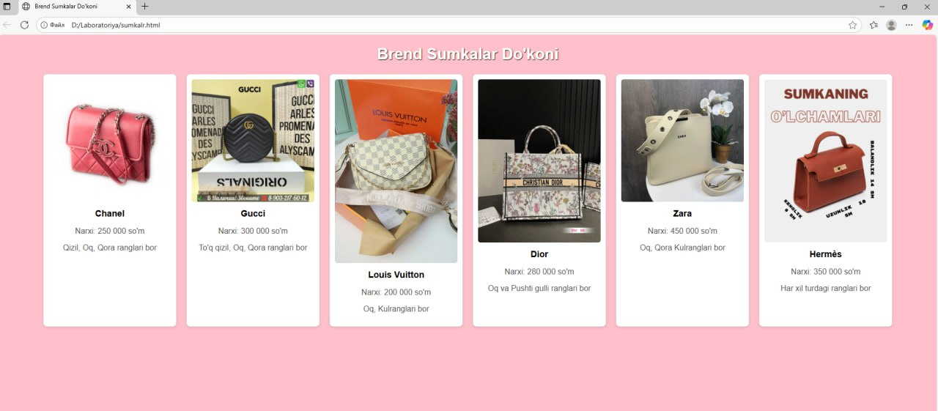

5. Xulosa
Ushbu laboratoriya ishida CSS media queries yordamida veb-sahifani responsiv (moslashuvchan) qilish yo‘llari o‘rganildi. Ushbu yondashuv mobil qurilmalarda foydalanuvchi tajribasini yaxshilaydi va dizaynning universalligini ta’minlaydi.

